Photo illustrations of Gaze bag (Grade #50) used in the home
as Multi-function product.

.

Photo 1 (a & b) : Views of the gauze bag (Grade #50) after machine wash
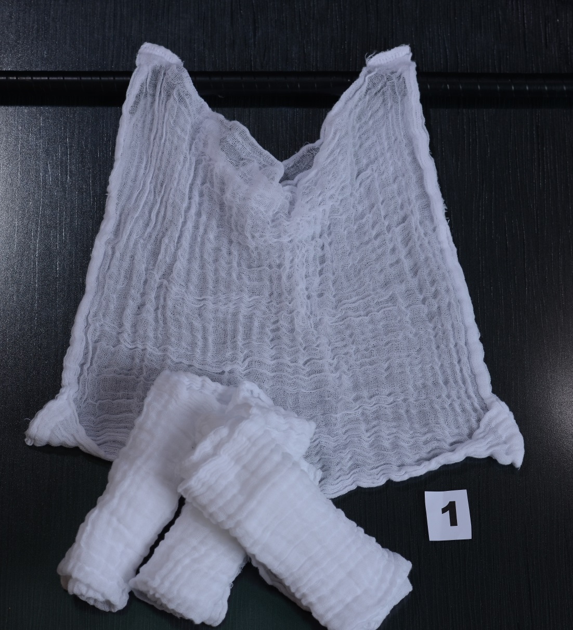
1-a
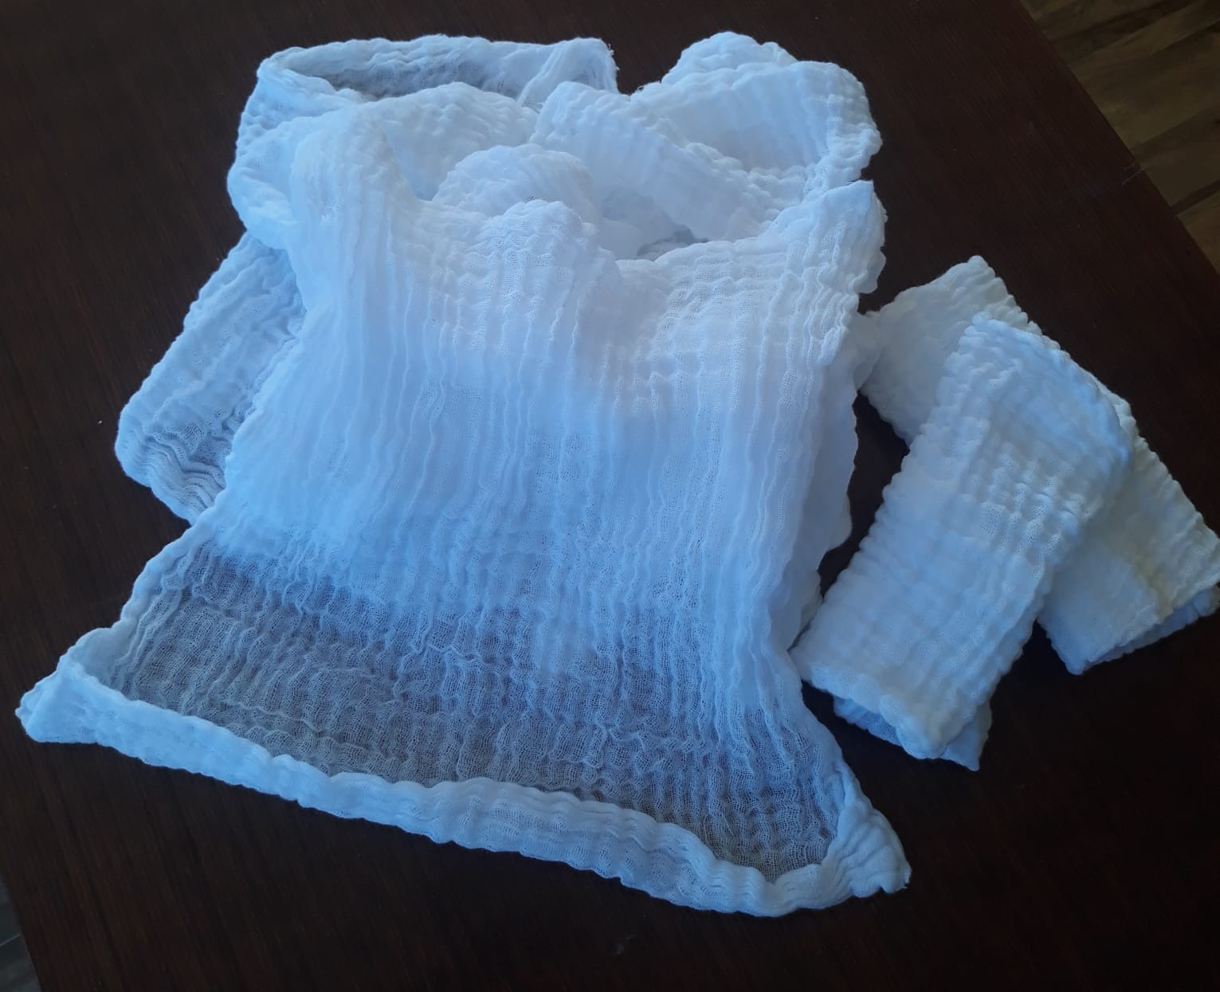

1-b

Photo 2: View of gauze bag (after machine wash) used as Infants Diaper Inserts

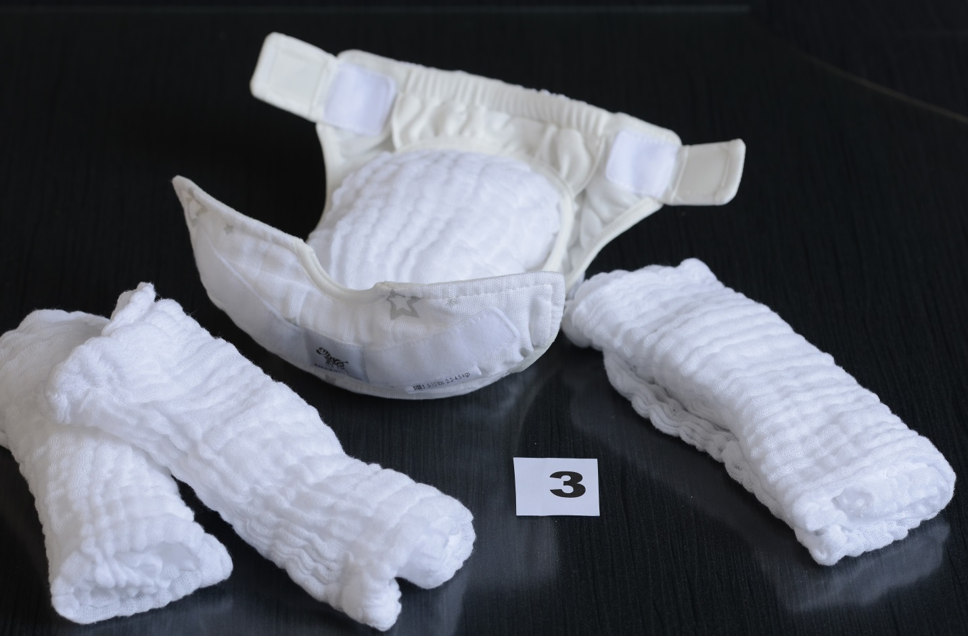

Photo 3 (a, b & c ): Baby gauze Diaper inserts & Burping/Spit-up Cloths sold in the market



3-a

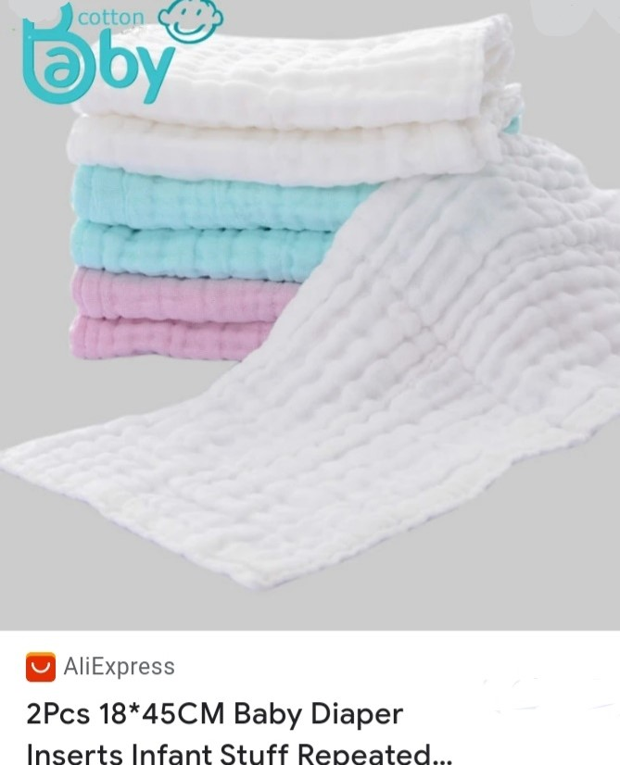

3-b

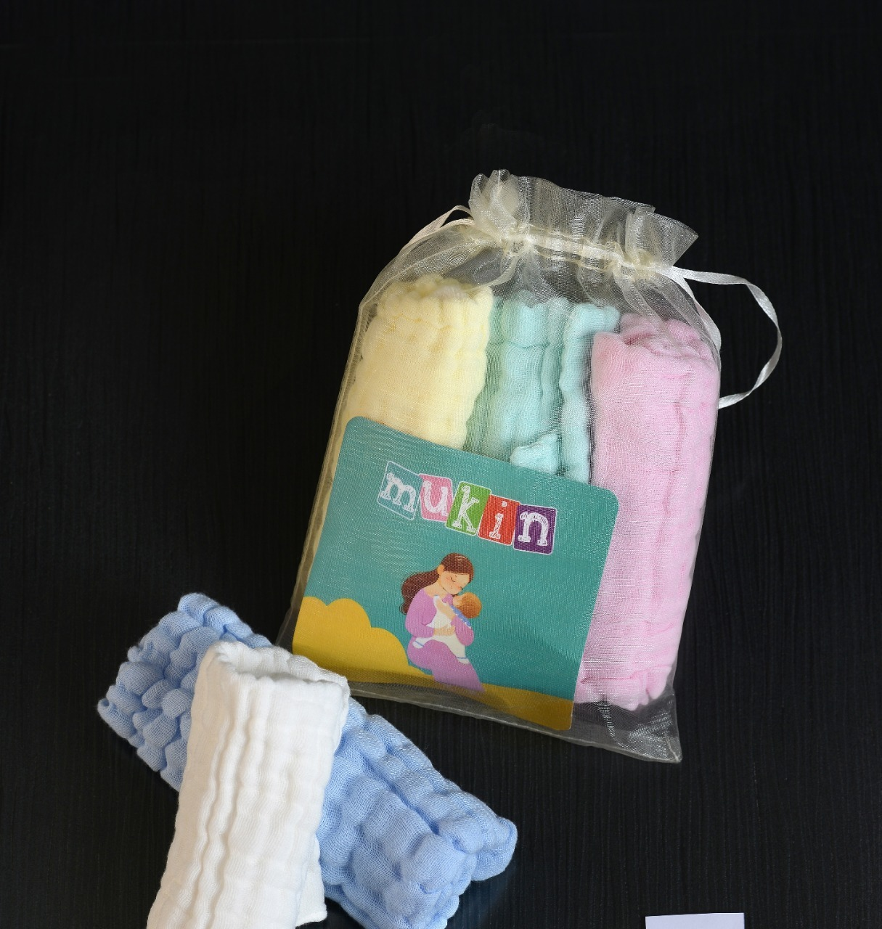

3-c

.

Photo 4: View gauze bag used as cleaning cloth/paper towels for cleaning surface in kitchen
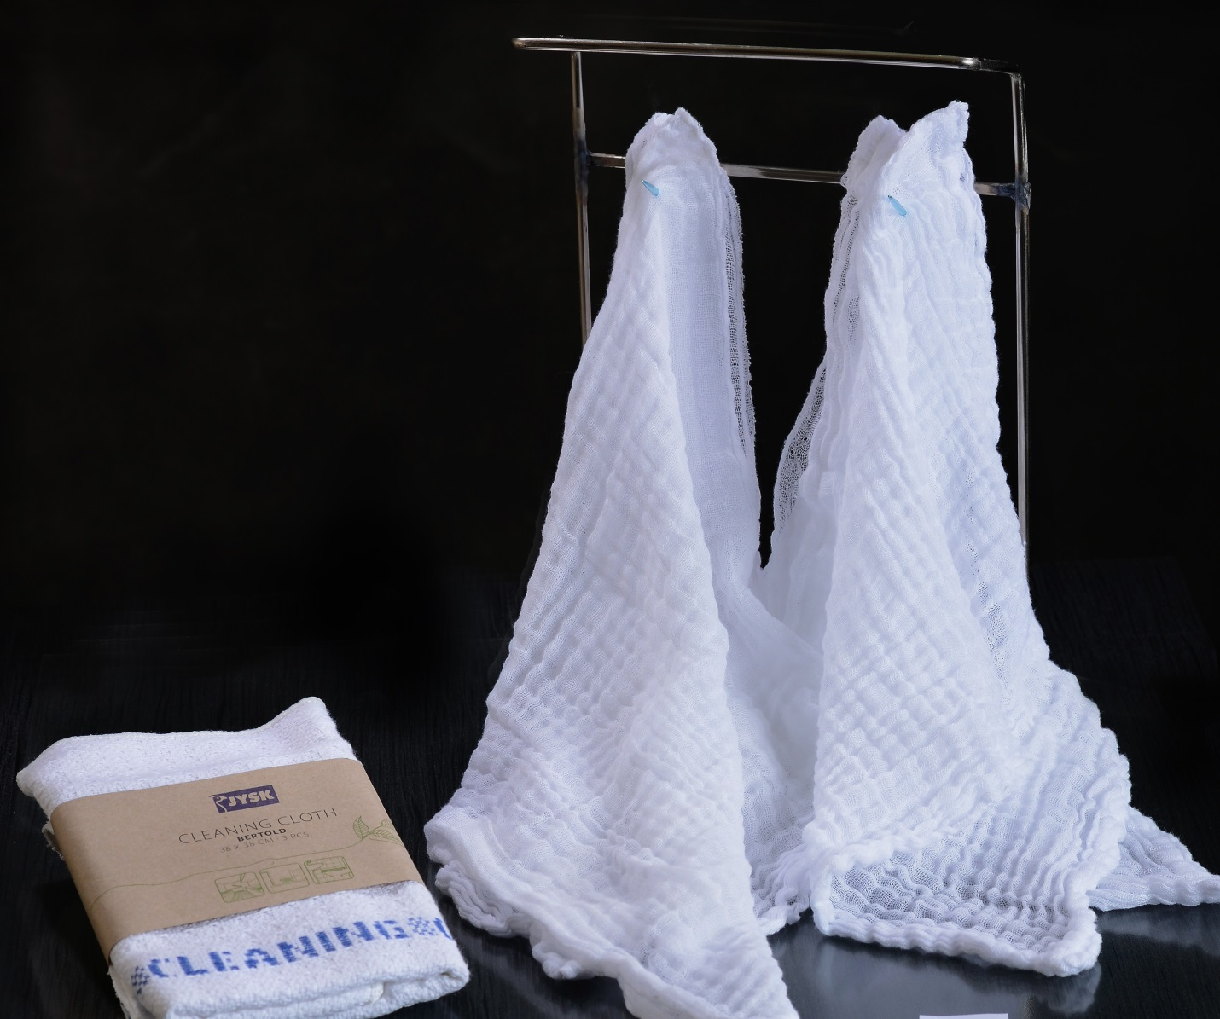

Photo 5 (a & b): Gauze grocery bag (Grade # 50) used as non-liquid, Dry-trash bag
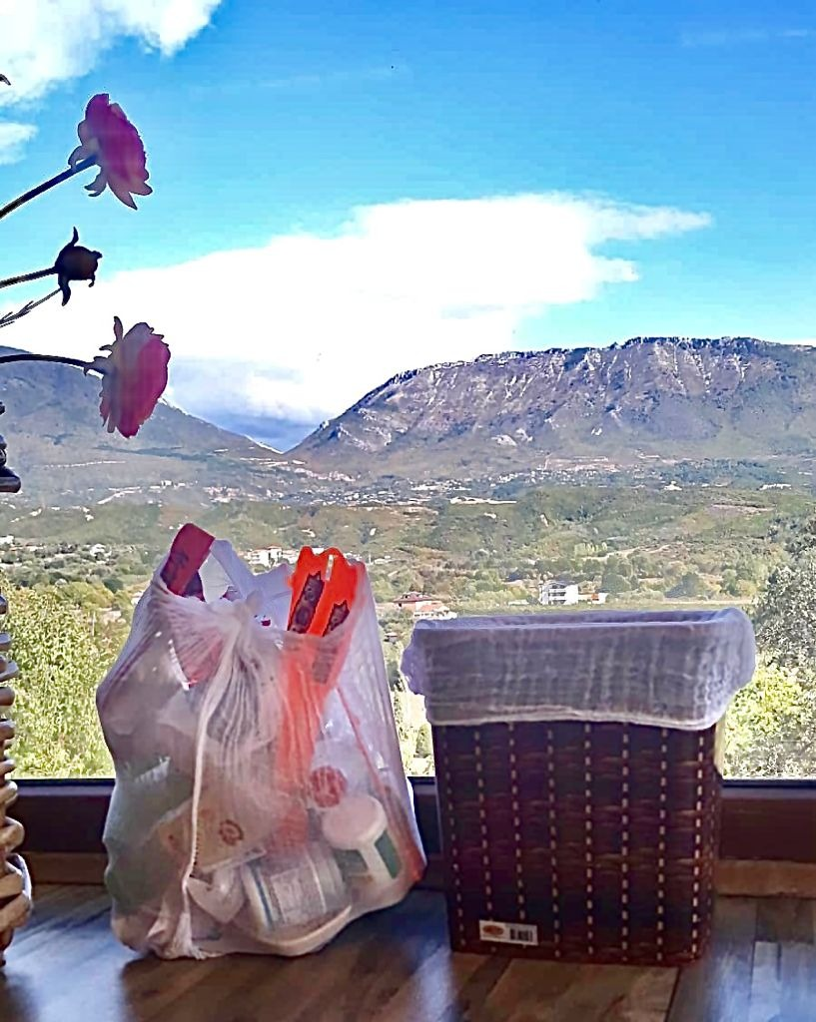
5-a
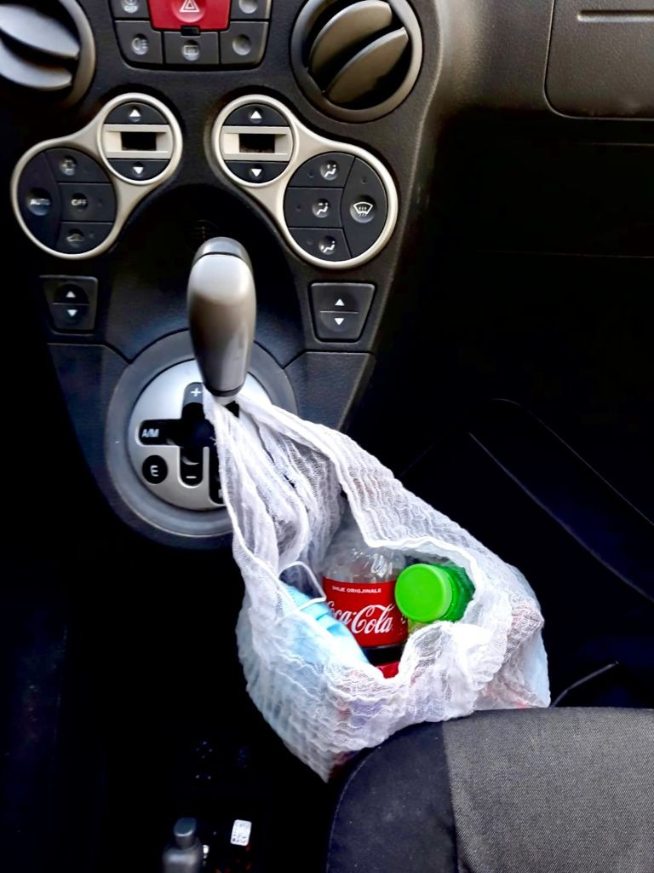
5-b
Photo 6: Gauze bag Grade # 50 filled with groceries
