Title: Life cycle of cotton gauze grocery bag in support of sustainability

Description of Invention
Part A-Design
The present invention offers the most cost-saving, effective alternative of Handle design for the grocery bag that will reduce up to 30 % of Textile, Fuel, Manpower and Energy
there are two traditional bag handle designs most often available in the market. "Attached" and Cutout Holes* handle designs applied to any kind of woven and non-woven fabrics.
This invention offers a new design that features handles incorporated into the body of the bag with fabric INTACT - one square piece 45 x 45 cm.
Handles are created by leaving a gap during the sewing process (break on sewing ) of around 16 cm on both sides of the bag .The 16 cm gap acts as handle and allow the user to carry the grocery bag with a firm grip.
This unique handle design uses up to 30% less fabric and fuel for its transportation, up to 9 times less Manpower and Energy Vs traditional grocery bags in the Market.
For *Detailed Competitive Analyses* of this new handle design VS traditional ones see *Economic Context* section below.
Further more due to its simplicity the new design will allow the bag to be produced in mass.
It is highly beneficial to make Textile manufactures ( particularly bag manufacturers) aware of this new design which is clearly very sustainable and economical. They should also consider that shoulder handles such as "Attached and Cutout hole" :are not necessary, especially for grocery bags which will be used from Store-to Cart-to Car- to Home.
The most important point is that this sustainable solution does not need any additional investments in infrastructure or machinery to be implemented.
The grocery Bag Manufacturer needs to simply replace the use of traditional "Attached or Cutout Hole:" designs with this new one in the same location with the same machinery
.Living on our time when the global warming crisis is one of the biggest concerns our planet is facing, a new and improved handle design of any kind of fabric (rayon, synthetic or cotton) used for reusable grocery bags can do it's part in support of the United Nations Sustainable Development Goals (SDGs). Specifically, Goal 12: "by 2030 achieve the sustainable management and sufficient use of natural sources."
Part B- The never-ending life cycle of cotton gauze grocery bag.
Design (Part A) is the first step of this invention in support of sustainability that can be applied to any kind of woven and non-woven fabrics.
However this invention offers also another alternative: "The never-ending Life cycle of cotton gauze grocery bag"
A combination of this simple design with the lightest and most absorbent possible cotton gauze fabric will make the grocery bag "A multi-function" that later can easily unfasten to be used as replacement of many cotton Items at home such as:
-Washable cotton Diapers Inserts/pads.
-Burping/Spit-up Cloth for baby
-Replace Dishcloth and cleaning cloth used for general cleaning
-Use as cotton napkins in kitchen to replace paper towels.
-and also be washed, and reused for all of the above, including as a reusable grocery bag if needed:
A final incredible use for the gauze bag in the home is to use it as a trash bag.
There are many rooms in a home where non-liquid, dry trash is thrown out. These rooms may include libraries, bedrooms and children play rooms. They may even be easily and conveniently stored in cars and used to collect and throw out trash that so easily accumulates there
Two of the greatest advantages of using the gauze bag as a dry trash bag include:
1. Reduced reliance on plastic bags.
2. Prohibits bacterial growth and odors from coming through the trash can due to the highly breathable and quick-dry properties of the gauze fabric.
For Photo illustration of its multi-function see the link below:
https://www.dropbox.com/s/6xq7vcpv3lczpcl/Photo%20Illustrations.pdf?dl=0
Invention was created with this question in mind:
"""How to combine the lightest and most absorbent possible cotton material with a unique grocery bag design that after bringing our grocery at home can replace all of above""".
A combination of gauze cheesecloth (preferably grades #50 -70) fabric with this new handle bag design can produce a life cycle gauze grocery bag..
For more information about the life cycle product please see the publication of this invention to the European Circular Economy Stakeholder Platform
https://circulareconomy.europa.eu/platform/en/good-practices/never-ending-life-cycle-cotton-gauze-grocery-bag

Here there are some more facts:
***This cotton gauze Diaper Insert is more absorbent than the microfiber or bamboo versions commonly sold in the market. Cotton retains moisture under pressure better than microfiber or bamboo (the same applies for all other cotton items that gauze bag will replace at home).
***Cotton production worldwide is around 25 million ton/year. In order to be able to replace all 400 billion single use plastic grocery bags around the world., around 7 million tons of cotton per year will need to be produced if we replace them with gauze bags grade #60, which only weigh about 17gr each.
If gauze bag (grade # 60) is washed and return to market at least four times, the cotton amount of grocery bags will be reduced to 2 million ton cotton/year. This amount will not only replace all plastic bags but at the same time will continue to be reused at home as a life cycle product, thus drastically reducing the cotton production for other items already manufactured and shipped separately by the Textile industry as a single product to different stores.
***Each of grocery bags presently in the market has their own problems.
A- Plastic shopping bags that are the only mass produced single use grocery bags in the market are now an omnipresent global product due to having a devastating impact on human health and our environment.
B- Heavyweight Reusable shopping bags that are brought in the market to replace plastic bags have even more problems:
- They are thicker, heavier, and not very comfortable to be washed every time after been used, bringing a hygiene issues that arise by which can become dirty with time thus heightening the danger of spreading food-borne illness.
Reference: https://www.dailymail.co.uk/news/article-5894537/Supermarket-staff-discover-mice-dirty-nappies-used-NEEDLES-reusable-bags-plastic-ban.html
In this age of food related epidemics, customers and food purveyors will be ever more mindful of cross-contamination.
The present invention can help reduce the hygiene issues and solve those concerns
-Tote reusable bags” being thicker and heavier they have lower water absorption properties plus their design with attached handles not allowing them to be multi-function.
The present invention offers a multi-function product that will saves the customer money in the long run, and additionally will be in support of sustainability
C- Paper bags. There are several benefits of gauze bag over paper bags.
- Paper bags rely on cutting trees that requires years to grow up
- They are prone to wetness. This condition does not affect the gauze bag
- The Gauze bag can also be used as a cleaning cloth, which also reduces the usage of paper towels at home.
- Paper bags are heavier and require more fuel for their transportation.
I have based some of the following comparison points on information obtained in the following website: https://www.nashvillewraps.com/blog/2008/04/17/paper-bags-versus-plastic-bags-real-numbers
(Note: Nashville Wraps sells both paper and plastic bags)
According to this article the weight of 1000 paper bags is around 140 lbs.
The weight of 1000 gauze bags (grade #60) is around 37 lbs.
This weight difference will affect the transportation costs: around 3.7 time more gas for each full truck load will be need for paper bags Vs gauze bags
***Regarding the hygiene issues arise from Tote Reusable bags mention above the problem is solved by presenting a design of grocery bag “that instead bringing Tote reusable bag 150 times back into food selling establishments (,as required for heavy tote/canvas bags) the bag can be used and reused at home as a replacement of many Items that we normaly buy separately in the market., or if needed
we can reuse it 4-5 times as reusable bags..
***The new grocery bag design in shape of one square piece with no attached handles makes it easily unfasten to turn the bag to a cleaning cloth. Diaper Inserts, cotton napkins etc.
***Furthermore, function as a cleaning cloth will replaces some of the uses of the traditional paper-towels saving the user money and reduce reliance on trees for paper products.
***Since the gauze fabric is thin and light, the bag requires very little storage space, making it convenient to be machine washed and saved on the kitchen drawer to used whenever needed.
***Sanitary advantages:
Cleaning sponges and non-woven dishcloths available in today's market do not allow air to pass through easily thus become breeding ground for dangerous food-borne bacteria. The tiny air holes in the lower grade gauze fabric not only give it higher water-absorption properties, but also allow it to quickly air dry.
This unique aspect of the gauze fabric makes it extremely sanitary and especially valuable for use in the kitchen where food is handled and the spread of disease carrying bacteria is more commonly found

Economic context
Detailed Competitive analyses of New design VS traditionally grocery bags design
1- New Handle design (Photo 1) features handles incorporated into the body of the bag with fabric INTACT - one square piece 45 x 45 cm. Another aspect of the invention provides a bag design of having “Self-finished edges” (Selvage) of fabric to be on the opening part of the bag which will reduce sewing costs.
-Body size = 0.45 m2 fabric
-0.50 Linear meter of hemming/ 19.6 Linear inches.(around 15 sec machine sewing)
-No extra fabric on Handles
-No extra Fuel to transport on handles
-No extra energy and manpower on making the handles
2. "Attached Handles" design (Photo 2)
This is an example sold on Amazon:
https://www.amazon.com/dp/B07F6WL121/ref=cm_sw_r_em_apan_glt_fabc_N2VRMF0DY0SKW9C87DZG
***Analysis of extra fabric and Fuel needed for “Attached handles”( Photo 2)
According to the manufacturer’s description:
Body of the bag fabric: 14 x (13.5 + 8+ 13.5+ 8) = 602 In2 fabric
Two Bag Handle : 2x (24 x 3.5 inch) = 168 In2 fabric used for both handles
602+ 168= 770 In2 total fabric/bag.
Out of 770 In2 fabric 168 In2 will be used for handles =21.8%
Conclusion:
21.8 % fabric/bag will be needed for Handles
21.8 % fuel will be needed for transporting of 168 In2 fabrics for handles
ALL of above will be saved if the Bag Manufacture will implement the “New handle design “where handles are incorporated to the body of the bag (see photo 1)
**Analysis of extra energy and manpower for "Attached handles"
Manpower and energy will be needed for machine sewing of double stich on top hemming on handles and opening of the bag
Machin sewing, hemming on Handles:
2 handles x 24 inch long = 48 inch hemming
Machine sewing, hemming on opening of bag
13.5 + 8 + 13.5 +8 = 43 inch perimeter
Total 43 + 48 = 91 inch long; double hamming = Total 182 Linear inches hamming
182 linear inches Vs 19.6 Linear inches on new design.
9.2 times less Energy and Manpower will be saved if the Bag Manufacture will implemented the “New Handle design”
3. "Cutout Holes" design (Photo 3)
This traditional handle design is achieved by disposing a part of the fabric to create the handles.
Here is another example from Amazon::
https://www.amazon.com/dp/B08PCK83DY/ref=cm_sw_r_em_apan_glt_fabc_QM1MPPYWDHW9Y2Y204MQ
****Analysis of extra fabric and Fuel needed for "Cutout Holes" design (Photo 3)
According to the manufacturer’s description:
Fabric for body of the bag : 12.8 x (13.3+ 3,9 +13.3 +3.9) = 440 In2 fabric
Fabric used for 'Handles part' of the bag: 13.3 x (3.9 +13.3+3.9+13.3)= 458 In2 fabric
==========
Total fabric (Handle and body) = 898 in2
-Around 1/3 of 458 In2 (Handles part) is disposed:= 149 In2 (17 % of fabric is wasted during manufacturing)
-Around 2/3 of fabrics is used as handles = 299 In2 (33 % of fabric are used on handles)
Conclusion:
Out of 898 In2 total fabric:
17% will be Disposed
33 % will be used on handles
33% Fuel will be used to transport handles
ALL of above will be saved if the Bag Manufacture will implemented the “New handle design “where handles are incorporated to the body of the bag (see Photo 1)
****Analysis of extra energy and manpower for "Cutout Holes" design (Photo 3)
Manpower and Energy will be needed for machine sewing on hamming cut edges
8 sides x 13.3 inch = 106 Linear inches machine sewing
106 Linear inches Vs 19.6 Linear inches on the “New Handle design”
5.4 times less Energy and Manpower will be saved if the Bag Manufacture will implemented the “New handle design “
4- Here is another illustration (Photo 4)
This is the bag with the logo “Horizon 2020 of European Commission Research and Innovation” where extra fabric to make the attached handles goes up to 20.83% of the fabric.
-Total weight of bag = 38 gr
-Weight of the two handles “double stitched top hem”, 73 cm long = 10 gr
This indicates that for each 38 gr of cotton fabric, 10 gr. cotton is added to make the handles. That is equal to 20.83 % cotton fabric would be saved if new design would be Implemented to this bag.
5- Implemented the "New handle design" to “Horizon 2020” logo bag to make this competitive analyses more accurately (Photo 5)
When the "new handle design" was implemented to the “Horizon 2020” logo bag, the results were as follows:
-20.83% cotton fabric is saved by eliminating attached handles.
-20.83% transportation fuel would be saved when transporting the now lighter bag.
-8.8 times energy is saved by eliminating sewing process on 4.4 linear meters of hemming.
-8.8 times manpower is also saved as a result
Development of mass produce grocery bag w/new handle design in the following simple steps:
(1) Use fabric with self-finished edges (designed to be at the opening of the bag) that is packed in the big rolls with 100 cm (or 1 yard) in width and with unlimited length.
Note: Self-finished edges at the opening of the beg will reduce sewing costs for the grocery bag (such as Manpower and Energy)
(2) Cut 50 cm fabric that will be needed for each bag, creating a piece of 50 cm x 100 cm
(3) Fold 2-3 cm onto itself both "cut sides of 100 cm" that has lose fray edges, to prevent them from unraveling when the bag will be washed and reused as cleaning cloth, Diapers inserts, cotton napkins etc
..
(4) Fold the fabric to create a shape of the “bag” 45x45 cm
(5) Sew the bag on both sides by living “16 cm gap” to create handles
(6) Before finishing the sewing process folds the bottom 5 cm upward to create the bottom of the bag enable it to carry objects more steadily while holding the shape of the bag

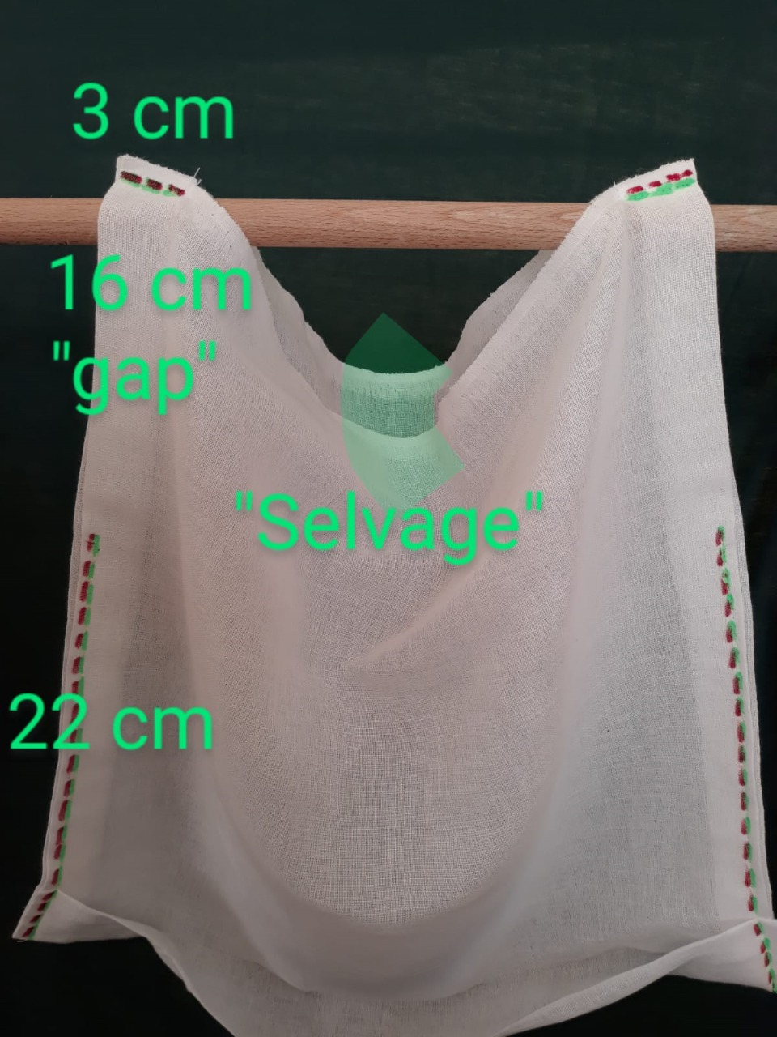Photo 1
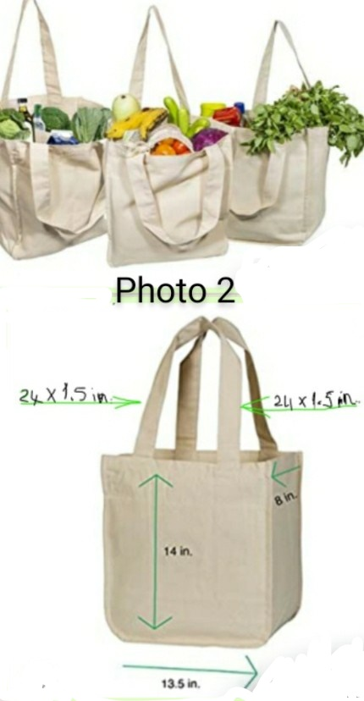Photo 2
Photo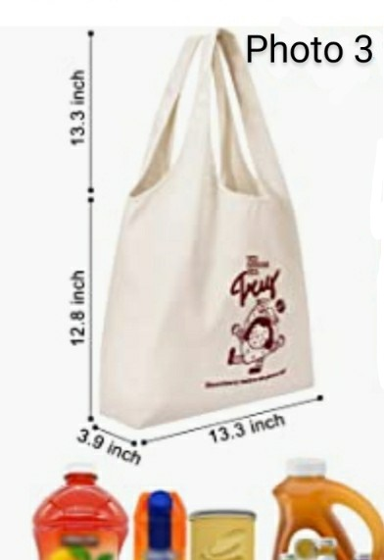 3

